**Lab 3**

**Variable**

**Function 9 : is use to display string on screen**

**LEA :This instruction load address of variable in destination register.**

**Offset : Put address of variable (which contain string) in the destination register.**

**Object:** To display a string on the screen.

**Assembly Code:**

.model small

.stack 100h

.data

str1 db 'Sindh Madressatul Islam University$' ;define byte

.code

main proc

;initialize ds

mov ax,@data ;name of data segment defined by .data

mov ds,ax ;initialize ds

;display string

lea dx,str1 ;get string

mov ah,09h ;display string function

int 21h ;display string

;return to DOS

mov ah,4ch ;exit program with return code

int 21h ;DOS exit

main endp

end main

**2. To display string on screen. (offset)**

. model small

. stack 100h

.data

msg db " Hello world$"

.code

start:

mov ax,@data

Mov ds,ax

mov ah,09

mov dx, offset msg

int 21h

mov ah,4ch

int 21h

end start

**2. Display String on new line.**

.MODEL SMALL

.STACK 100H

.DATA

STRING_1 DB 'SMI$'

STRING_2 DB 'University $'

. CODE

MAIN PROC

MOV AX, @DATA ; initialize DS

MOV DS, AX

LEA DX, STRING_1 ; load & display the STRING_1

MOV AH, 9

INT 21H

MOV AH, 2 ; carriage return

MOV DL, 0DH

INT 21H

MOV DL, 0AH ; line feed

INT 21H

LEA DX, STRING_2 ; load & display the STRING_2

MOV AH, 9

INT 21H

MOV AH, 4CH ; return control to DOS

INT 21H

MAIN ENDP

END MAIN

**Lab Task:**

**1. Assembly code displaying bio data (multiple strings) on new line.**

**Assembly Code displaying bio data (multiple strings) on new line:**

.model small

.stack 100h

.data

str1 db 'Name: Ali.$' ;define byte

str2 db 'Roll no.: 14cs01.$'

str3 db 'Batch: 4A.$'

str4 db 'University: Sindh Madressatul Islam University.$'

.code

**main proc**

**;initialize ds**

**mov ax,@data ;name of data segment defined by .data**

**mov ds,ax ;initialize ds**

**;display string**

**lea dx,str1 ;get string**

**mov ah,09h ;display string function**

**int 21h ;display string**

**mov dl,10 ;line feed**

**mov ah,02h**

**int 21h**

**;display string**

**lea dx,str2 ;get string**

**mov ah,09h ;display string function**

**int 21h ;display string**

**mov dl,10 ;line feed**

**mov ah,02h**

**int 21h**

**;display string**

**lea dx,str3 ;get string**

**mov ah,09h ;display string function**

**int 21h ;display string**

**mov dl,10 ;line feed**

mov ah,02h

int 21h

;display string

lea dx,str4 ;get string

mov ah,09h ;display string function

int 21h ;display string

;return to DOS

mov ah,4ch ;exit program with return code

int 21h ;DOS exit

main endp

end main

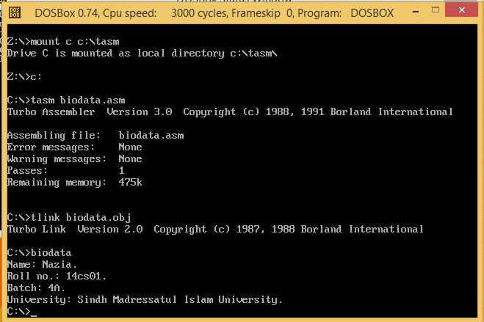

**Lab Task:**

**1. Assembly code displaying bio data (multiple strings) on new line.**

**Source Code:**

.model small

.stack 100h

.data

var db "**********************$"

car db "Enter Your Name:$"

bar db "Enter Your Father Name:$"

mar db "Enter Your Roll NO:$"

war db "Enter Your Institute Name:$"

tar db "**********************$"

.code

start:

mov ah,09

lea dx,var

int 21h

mov ah,02

mov dl,0ah

int 21h

mov ah,02

mov dl,0dh

int 21h

mov ax,@data

mov ds,ax

mov ah,09

lea dx,car

int 21h

mov ah,02

mov dl,0ah

int 21h

mov ah,02

mov dl,0dh

int 21h

mov ah,3fh

int 21h

mov ah,02

mov dl,0ah

int 21h

mov ah,02

mov dl,0dh

int 21h

mov ax,@data

mov ds,ax

mov ah,09

lea dx,bar

int 21h

mov ah,02

mov dl,0ah

int 21h

mov ah,02

mov dl,0dh

int 21h

mov ah,3fh

int 21h

mov ah,02

mov dl,0ah

int 21h

mov ah,02

mov dl,0dh

int 21h

mov ax,@data

mov ds,ax

mov ah,09

lea dx,mar

int 21h

mov ah,02

mov dl,0ah

int 21h

mov ah,02

mov dl,0dh

int 21h

mov ah,3fh

int 21h

mov ah,02

mov dl,0ah

int 21h

mov ah,02

mov dl,0dh

int 21h

mov ax,@data

mov ds,ax

mov ah,09

lea dx,war

int 21h

mov ah,02

mov dl,0ah

int 21h

mov ah,02

mov dl,0dh

int 21h

mov ah,3fh

int 21h

mov ah,02

mov dl,0ah

int 21h

mov ah,02

mov dl,0dh

int 21h

mov ax,@data

mov ds,ax

mov ah,09

lea dx,tar

int 21h

mov ah, 4ch

int 21h

end start

**OUTPUT:**

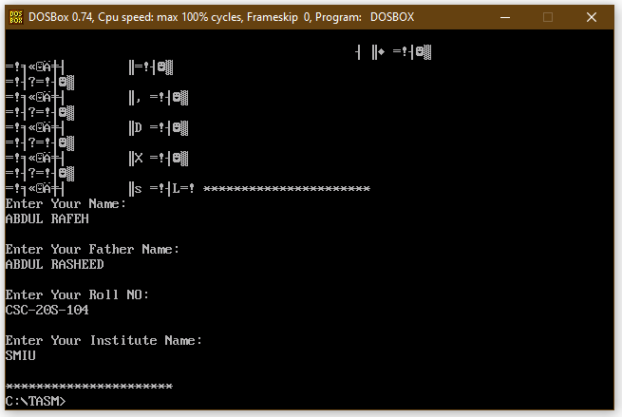

Problem I found in this program after given “$” symbol but garbage will also come.